

**Project Based Learning**

**Title of Project :** Food Delivery Service App: Design a user-friendly app for a food delivery service, optimizing the ordering process, delivery tracking, and customer support interactions

|  |  |  |
| --- | --- | --- |
| **Sr.No** | **Name of Students** | **PRN No** |
| 1 | Soumy Sen | B24IT1003 |
| 2 | Chetan Radhe | B24IT1012 |
| 3 | Ritesh Nikam | B24IT1019 |
| 4 | Pradeep Kawade | B24IT1032 |

**Date: Faculty In-Charge**

**CHAPTER 1**

**Introduction**

**1.1 Brief Overview of the Project**

* FlavourGo is a food delivery app focused on more than just convenience.
* It aims to help users become more conscious of their food spending.
* Inspired by popular finance apps and their features.
* Explores integration of budgeting tools, spending insights, and goal tracking.
* Uses a research-driven approach to support better financial habits related to food.

**1.2 Objective**

* Research, design, and evaluate financial tracking features within a food delivery context.
* Adapt effective financial UX patterns to help users:
* Monitor food-related expenses.
* Set meal budgets.
* Track financial goals related to food spending.
* Integrate these features seamlessly into the FlavourGo app.

**1.3 Importance of UX in Making Financial Tracking Simple and Accessible**

* UX helps simplify complex financial data into clear, actionable insights.
* Good UX design ensures budgeting and expense tracking feels intuitive and engaging.
* Key UX strategies include:
  + Intuitive layouts.
  + Visual aids like charts and graphs.
  + Minimal input effort from users.
* Aims to make financial awareness a seamless part of the food ordering experience.
* Empowers users to eat smarter and spend better.

**CHAPTER 2**

## **UX Research Report**

### **2.1 Research Methods**

### To inform the design of FlavourGo, a mixed-methods approach was employed, combining quantitative and qualitative research methods:

* Surveys: Online surveys were distributed to a broad audience to gather data on food ordering habits, delivery challenges, and feature preferences.
* Interviews: In-depth interviews were conducted with a smaller group of individuals to gain a deeper understanding of their ordering behaviors, frustrations, and needs.
* Competitive Analysis: A competitive analysis was performed to evaluate existing food delivery applications, identifying their strengths, weaknesses, and areas for differentiation.

### **2.2 Survey Results & Interviews**

Survey Insights

Common Delivery Challenges:

* Many users reported frustrations with hidden fees, unreliable delivery times, and confusing order tracking.
* Some users found it hard to discover affordable food options quickly during peak hours.

UserNeeds:  
 Key user needs identified were:

* Clear, upfront pricing without surprise charges.
* Fast and reliable delivery tracking.
* Personalized restaurant recommendations based on preferences and budget.

7.Key Pain Points Identified:

* Hidden service and delivery fees.
* Lack of reliable estimated delivery times.
* Difficult discovery of budget-friendly meal options.
* Overwhelming app layouts with too many choices.

Functional Requirements:

* User authentication (login, signup, password reset)
* Menu browsing with filtering (price, ratings, delivery time)
* Real-time order tracking
* Transparent billing summary
* Promo code management
* Customer support chat
* Restaurant and dish reviews and ratings

Non-Functional Requirements:

* Security (encrypted transactions, secure user data)
* Usability (easy navigation, accessibility)
* Performance (quick loading, real-time updates)
* Reliability (accurate order tracking, minimal errors)
* Scalability (handle large user volumes during peak times)

### **2.3 User Personas**

Persona 1: Mia Kapoor – The Student

* Age: 20
* Goals: Order affordable meals between classes and late-night study sessions.
* Frustrations: Limited budget; dislikes discovering hidden fees at checkout.
* Behaviors: Regularly uses food delivery apps 2–4 times a week; looks for discounts first.
* Motivation: Save time and money, minimize stress while studying.

Persona 2: Rahul Shah – The Working Professional

* Age: 34
* Goals: Get reliable, timely meals during hectic workdays.
* Frustrations: Late deliveries and poor customer support responses.
* Behaviors: Orders lunch daily to the office; values on-time delivery over cost.
* Motivation: Maximize work productivity and convenience.

Persona 3: Ananya Deshmukh – The Small Business Owner

* Age: 42
* Goals: Coordinate affordable meal deliveries for her employees.
* Frustrations: High fees for group orders; scheduling difficulties during peak hours.
* Behaviors: Bulk orders for teams twice a week; prefers pre-scheduled deliveries.
* Motivation: Ensure happy, fed teams without breaking the business budget.

### 

### **2.4 Journey Map**

Stage 1: Trigger/Awareness

Description:  
The user realizes a need to order food, triggered by hunger, lack of time to cook, or a social gathering.

User Actions:

* Decides to order food instead of cooking.
* Searches for a food delivery app or opens FlavourGo.

Touchpoints:

* Mobile app listing.
* Word-of-mouth recommendations.
* Advertisements on social media.

User Thoughts/Feelings:

* Hunger, urgency, desire for convenience.

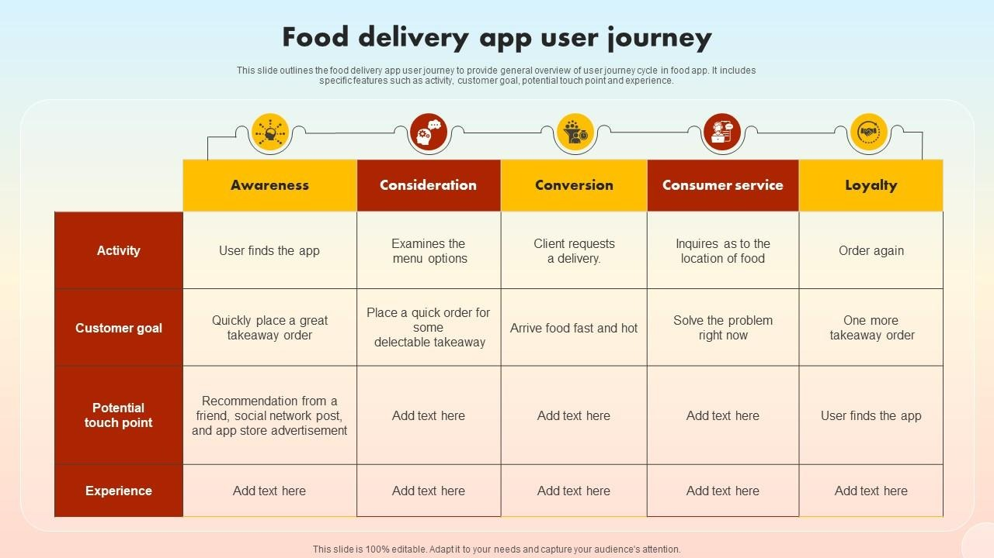

Stage 2: Onboarding

Description:  
The user downloads and starts using FlavourGo.

User Actions:

* Downloads the FlavourGo app from the app store.
* Creates an account using email or social login.
* Enters delivery address and payment preferences.
* Browses recommended restaurants and deals.

Touchpoints:

* App store page.
* App onboarding screens.
* Registration and location setup.

User Thoughts/Feelings:

* Curiosity, excitement, slight apprehension about app usability.

Stage 3: Browsing and Ordering

Description:  
The user searches for a restaurant and places an order.

User Actions:

* Applies filters (e.g., “Under ₹200,” “Fast Delivery”).
* Selects a restaurant and chooses dishes.
* Reviews order summary and cost breakdown.
* Applies available promo codes.
* Places the order and pays.

Touchpoints:

* Menu browsing interface.
* Restaurant profiles.
* Cart and checkout pages.

User Thoughts/Feelings:

* Excitement to eat, irritation if filtering and browsing are slow or confusing.

Stage 4: Order Tracking and Delivery

Description:  
The user monitors the status of their food delivery.

User Actions:

* Views real-time tracking of delivery partner.
* Receives status updates (e.g., order confirmed, food picked up, near arrival).
* Contacts support if needed.

Touchpoints:

* Order tracking screen.
* Push notifications.
* In-app chat with support.

User Thoughts/Feelings:

* Impatience or worry if updates are unclear or late.

Stage 5: Post-Delivery Experience

Description:  
The user receives the food and reflects on the experience.

User Actions:

* Rates the restaurant and delivery.
* Leaves feedback or a review.
* Shares promo codes with friends if incentivized.
* Decides whether to reorder from the same restaurant.

Touchpoints:

* Rating and feedback screens.
* Loyalty rewards page.

User Thoughts/Feelings:

* Satisfaction if experience was good; frustration if food was cold, late, or incorrect.

Pain Points:

* Hidden delivery and service fees not shown until checkout.
* Inconsistent delivery estimates leading to dissatisfaction.
* Limited clear filters for cheap meals or fast deliveries.
* Poor communication during order delays.
* Occasional app crashes or slowdowns during peak hours.

Opportunities:

* Upfront Pricing: Clearly display total costs earlier in the ordering flow.
* Smarter Recommendations: Suggest affordable, fast delivery meals based on user preferences.
* Better Tracking: Real-time map and progress bar for deliveries.
* Enhanced Support: 24/7 chatbot plus human assistance for escalations.
* Loyalty Rewards: Offer points, discounts, or free deliveries for repeat orders.
* Gamification: Badges or milestones for frequent users ("Fast Foodie," "Deal Hunter").
* Personalization: Dynamic homepage that adapts to the user's habits (e.g., "Your Tuesday Lunch Picks").

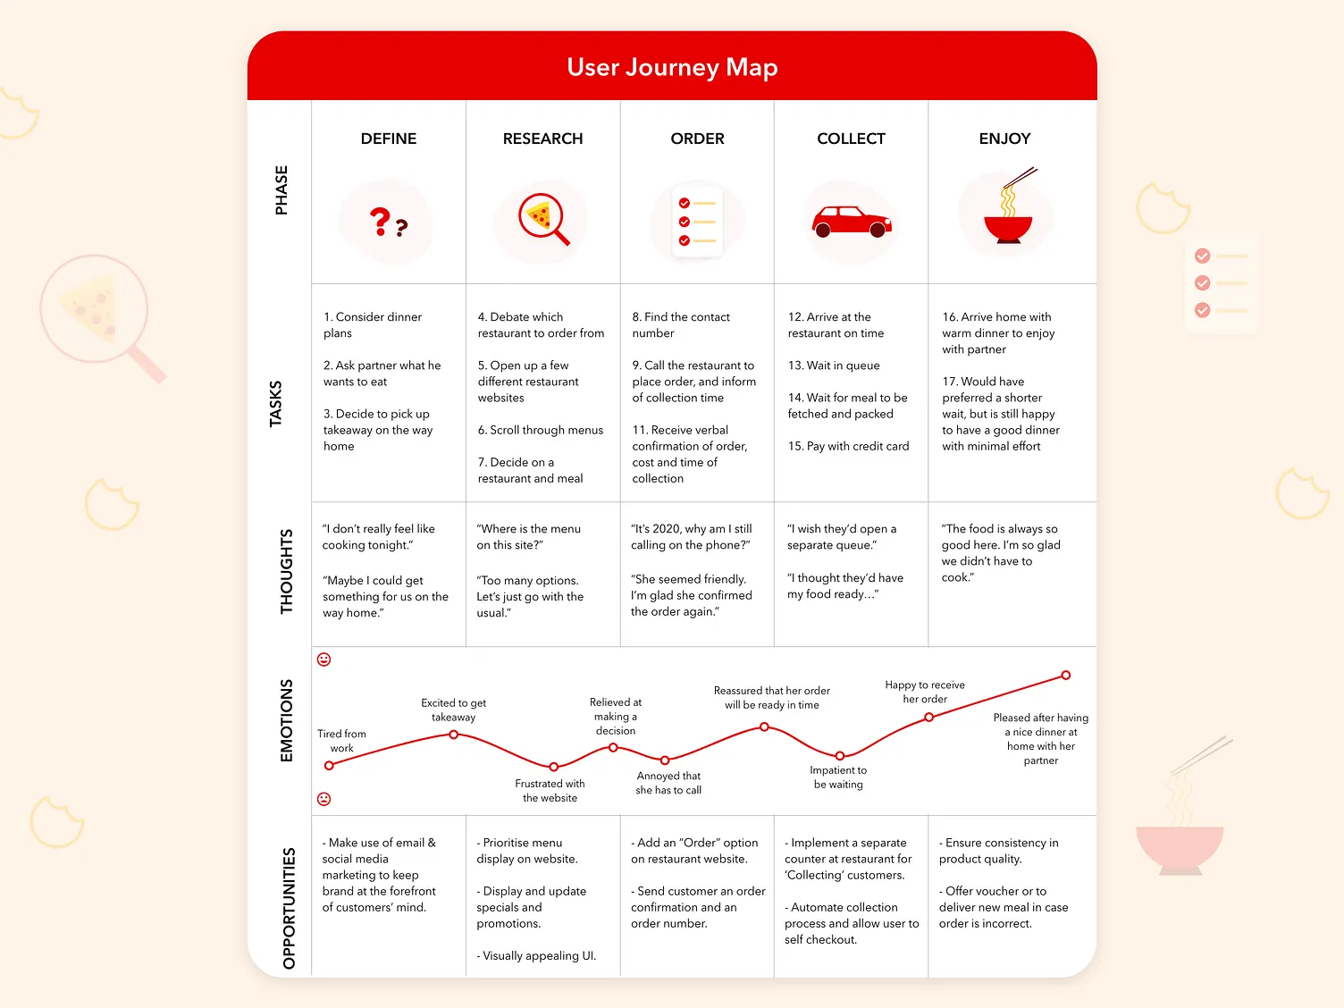

## 

**CHAPTER 3**

**UX Audit Document**

**3.1 Heuristic Evaluation of Existing Food Delivery Apps**

**Heuristic 1: Visibility of System Status**

**Description**: The system should always keep users informed about what is going on, through appropriate feedback within a reasonable time **Findings:**

* + **Issue:** On the login and password reset screens, there's no feedback indicator after clicking the button (e.g., “Reset Password” or “Sign in”), leading to uncertainty.

**Screenshot:**

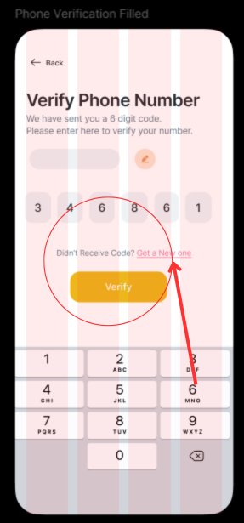

* + **Recommendation**: Include a loading spinner or progress indicator after the user taps "Login".

**Heuristic 2: Match Between System and the Real World — Satisfied Evidence:**

The app uses familiar terminology such as “Cart,” “Order History,” “Offers,” and “Delivery Partner”, closely reflecting real-world food ordering scenarios. Icons like a shopping bag, location pin, and clock help users map digital interactions to everyday tasks.

**Heuristic 3: User Control and Freedom — Satisfied Evidence:**

Users can navigate freely using the bottom navigation bar (e.g., “Home,” “Search,” “Cart,” “Profile”). During the ordering process, users can easily cancel or modify orders before final confirmation. The back button behavior is predictable and aligned with platform standards.

**Heuristic 4: Consistency and Standards — Satisfied Evidence:**

UI elements follow consistent design patterns. Primary actions such as “Place Order,” “Apply Coupon,” and “Pay Now” are always displayed as bold, colored buttons. Fonts, icons, and colors remain uniform across screens, maintaining visual harmony and platform guidelines.

**Heuristic 5: Error Prevention — Satisfied Evidence:**

The app prevents user errors by providing real-time validation (e.g., invalid coupon codes, missing delivery address). It prompts users when items are unavailable or minimum order limits are unmet before allowing the checkout process to continue.

**Heuristic 6: Recognition Rather Than Recall**

**Description:**

Minimize the user's memory load by making objects, actions, and options visible.

**Findings:**

* **Issue:** The “Reorder” section doesn’t display previously ordered item thumbnails or restaurant logos—users must recall what they ordered based on name alone.
* **Screenshot :**

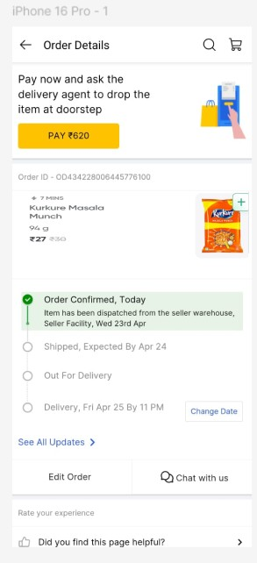

* **Recommendation:** Include visual cues such as dish images or restaurant logos in the reorder history to support recognition

**Heuristic 7: Flexibility and Efficiency of Use**

**Description:**

Support novice and expert users through shortcuts and advanced features.

**Findings:**

* **Issue:** Repetitive ordering requires multiple steps. No quick-order or voice assistant features exist for regular users.
* **Screenshot:**

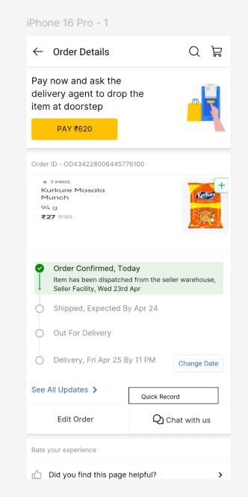

* **Recommendation:** Add features like **“**Quick Reorder”, “Recently Ordered Items”, or voice-based search to increase efficiency for frequent users. **Heuristic 8: Aesthetic and Minimalist Design** — **Satisfied**

**Evidence:**

The interface is visually clean, using a white background, consistent typography, and flat iconography. Only essential content is displayed per screen, with key actions like “Track Order” and “Rate Delivery” made prominent without overwhelming the user.

**Heuristic 9: Help Users Recognize, Diagnose, and Recover from Errors**

**Description:**

Error messages should be expressed in plain language and precisely indicate the problem.

**Findings:**

#### **Issue Identified:**

* **Missing "Resend OTP" Button** during the verification process..
* **Screenshot:**



**3.2 Key UX Issues Identified (Across Apps)**

Based on the heuristic evaluation, several key UX issues were identified across the analyzed food delivery apps:

* Cluttered Navigation and Browsing: Overloaded homepages and poorly structured menus make it difficult for users to efficiently find restaurants or dishes.
* Hidden Costs: Delivery and service fees not shown upfront create user frustration and mistrust.
* Complex Promotions and Discounts: Applying deals or vouchers is confusing or requires unnecessary extra steps.
* Overwhelming Search/Filter Experience: Offering too many filtering options without a clear structure leads to decision fatigue, especially for new users.
* Inconsistent Status Updates: In some cases, users reported vague or delayed updates about their order status, causing anxiety.

**-**

**Chapter 4**

**Task Flows & Sitemap**

**4.1 Task Flows**

A. Adding Income/Expenses

Task Flow: Paying for a Food Order

1. Open App → User lands on the Home screen.
2. Browse/Search Restaurants → User explores cuisines or searches for specific dishes.
3. Select Food Items → Items are added to the cart.
4. Tap on Cart → User reviews the order and modifies if needed.
5. Proceed to Checkout → Selects delivery address and payment method.
6. Enter Payment Details (if necessary) → Card info, wallet, or UPI.
7. Tap “Pay Now” → Order is placed.
8. Order Confirmation Displayed → User sees payment confirmation and ETA.
9. Track Order in Real-Time → Until order is delivered**.**

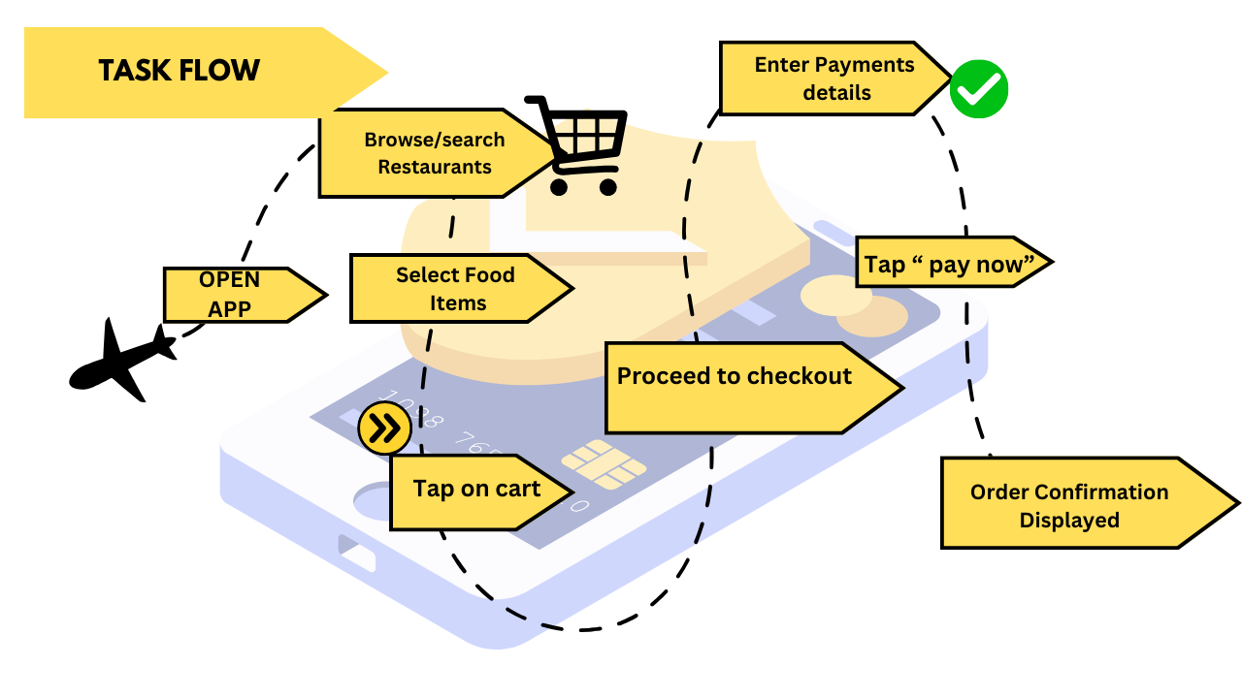

**B. Setting Financial Goals**

**Task Flow**: Setting a Food Delivery Budget

1. Open App → Navigate to Profile or Settings.
2. Access ‘Food Budget’ Section → (Could be a future feature).
3. Set Monthly Budget → Input amount (e.g., ₹2000/month).
4. Enable Notifications → App alerts when user is nearing the limit.
5. Monitor Spending via Order History → User reviews spending periodically.
6. Adjust Budget or Habits → Reduce orders or opt for discounted items**.**

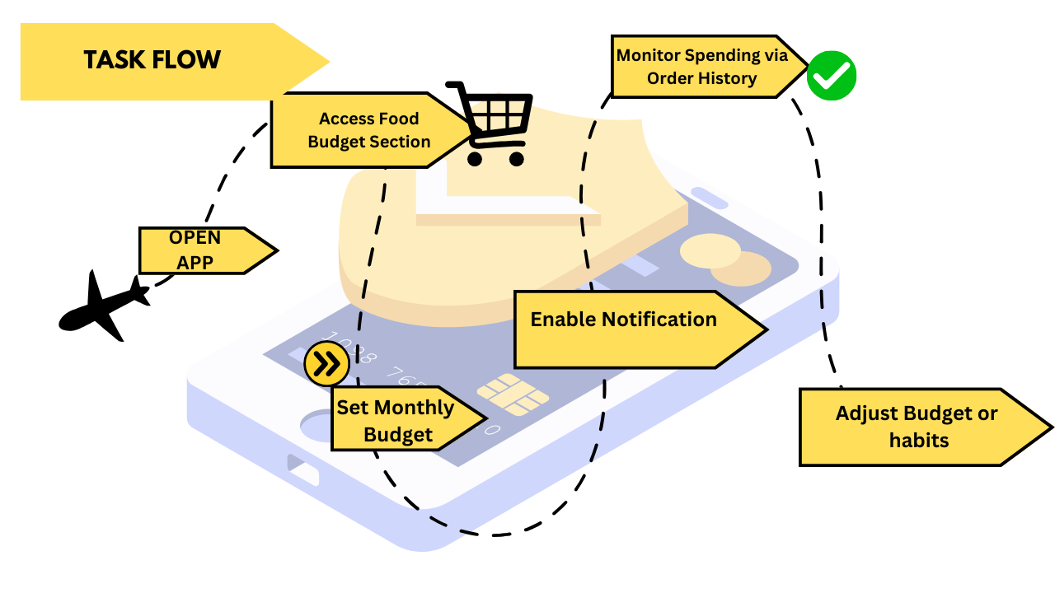

**C. Generating Reports**

Task Flow: Reviewing Order-Based Spending Report

1. Open App → Go to Profile tab.
2. Tap on “Order History”.
3. Filter by Month or Date Range → View past orders.
4. View Total Spent & Order Breakdown → Item-wise and restaurant-wise.

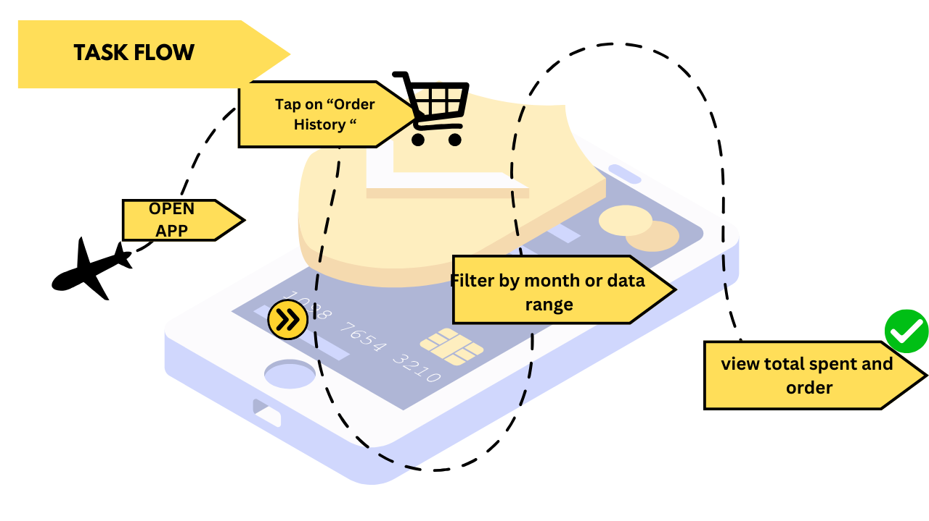

**D. Managing Budgets**

***(Reframes financial management as tracking and optimizing food delivery spending)***

**Task Flow: Managing Monthly Food Budget**

1. **Open App → Go to Profile or Settings.**
2. **Tap on Budget Tracker → (Future enhancement).**
3. **Review Monthly Spend Progress → Compared against preset limit.**
4. **Analyze High-Spending Categories → Frequent restaurants or expensive orders.**
5. **Make Adjustments → Use coupons, switch to affordable options, or reduce orders.**
6. **Monitor Weekly Updates → Stay on track with goals.**

**Site Map**

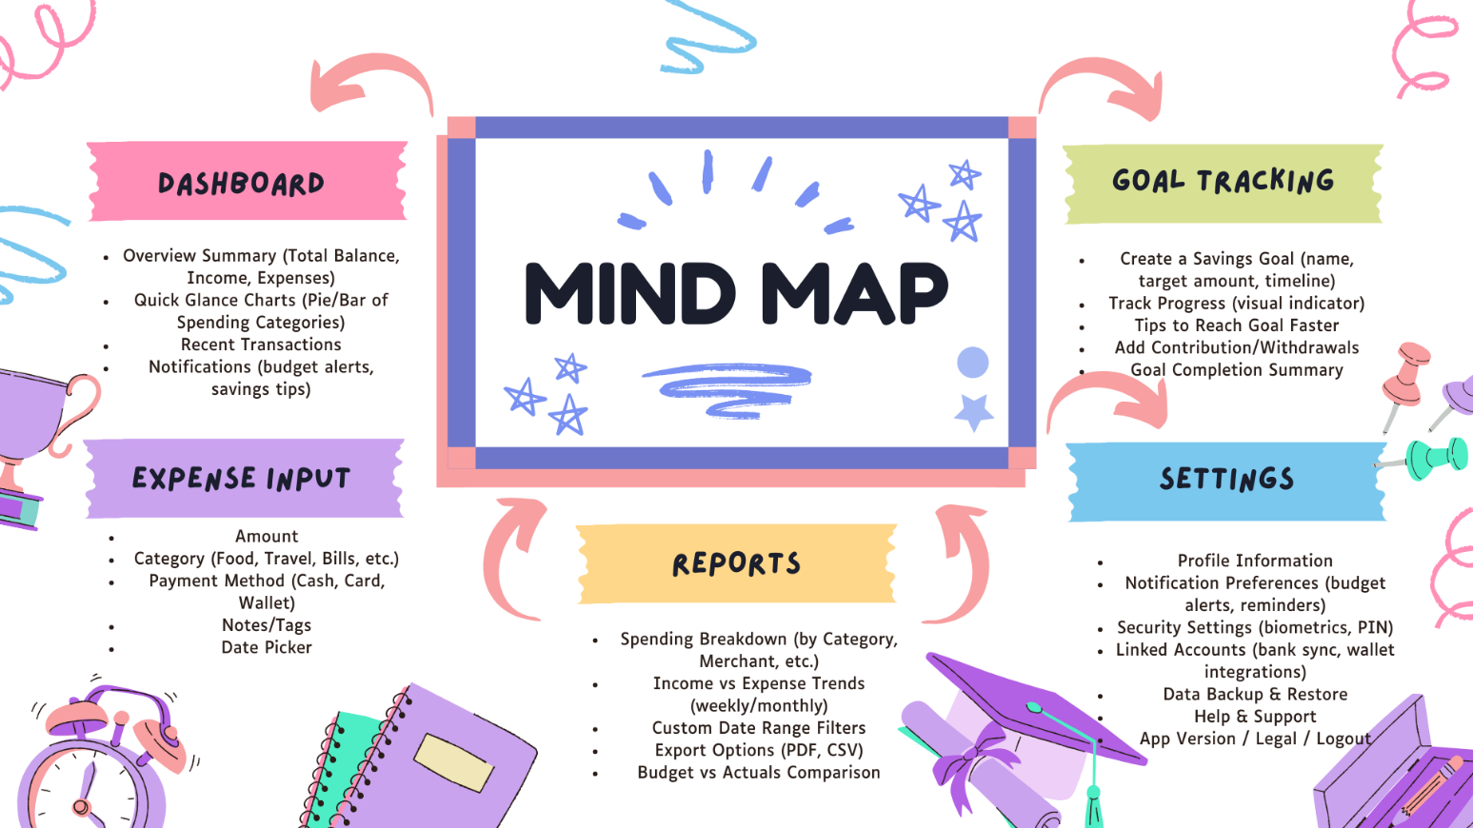

**Chapter – 5**

**Wireframes & Interactive Prototype (Figma)**

### **5.1 Low-Fidelity Wireframes**

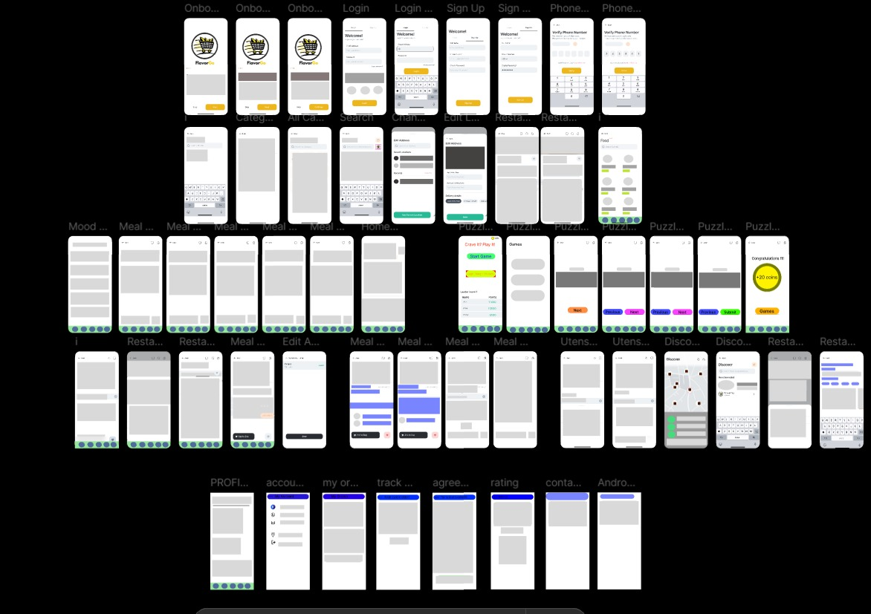

**5.2 High Fidelity Wireframe**

<https://www.figma.com/design/DcAAQsrNU27xCtb9SEIcnE/Food-Delivery-App?node-id=0-1&t=LvRjyoTjsqcLN7RD-1>

## **Chapter 6**

## **Style Guide (UI Components, Typography, Color Scheme)**

**Typography**

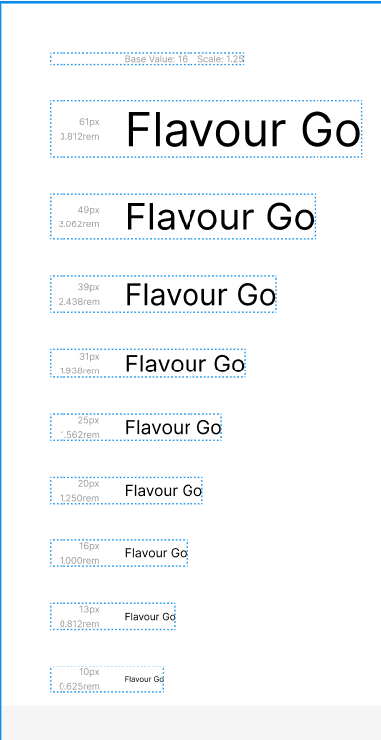

**Color Palette**

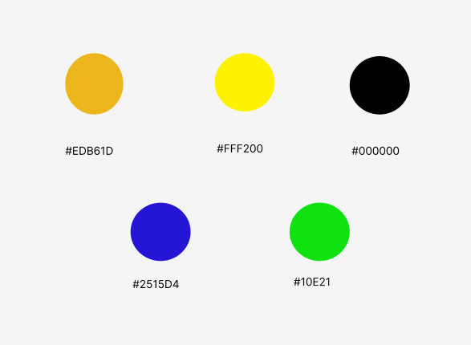



**UI Components** (Buttons, cards, tables, icons)

**Buttons :**

 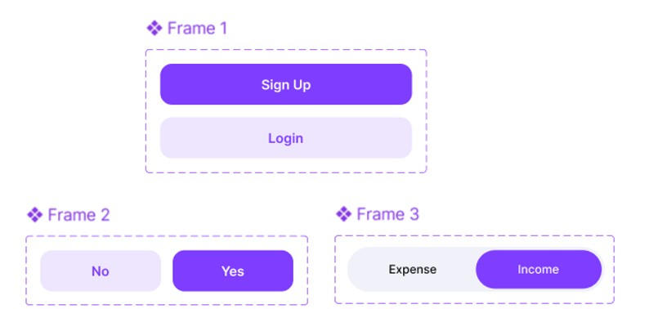

**Icons :**

 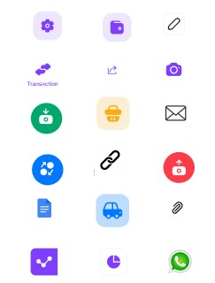

## **Chapter 7**

**Findings, Designs & Improvements**

**7.1 Key Research Insights**

Based on the UX research (outlined in Chapter 2), the following key insights significantly influenced the design of FlavourGo:

* Need for Simplicity:  
  Users strongly emphasized the desire for a simple and intuitive app experience to quickly find restaurants, place orders, and track deliveries without confusion. This highlighted the need for clean layouts, minimal steps for ordering, and clear navigation paths.
* Importance of Visual Clarity:  
  Users wanted a clear presentation of essential information like estimated delivery times, delivery fees, and current order status. This influenced the design to prioritize high-contrast layouts, prominent CTAs (Call-to-Actions), and concise summaries.
* Streamlined Onboarding:  
  To minimize user drop-off during onboarding, the app features a quick sign-up/login process with social login options and optional onboarding tips.
* Efficient Ordering Process:  
  Users preferred fewer steps from restaurant selection to order confirmation. The app’s design focuses on a seamless browsing-to-checkout experience with persistent carts and easy customizations.
* Personalized Recommendations:  
  Many users expressed interest in personalized restaurant suggestions based on their preferences and order history. This led to the inclusion of curated lists like "Top Picks for You" and "Reorder Your Favorites."

### **7.2 Final Design Showcase**

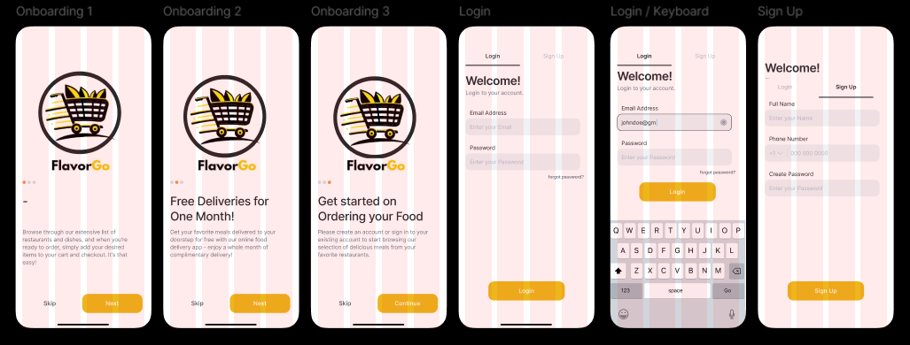

## 

## 

## 

## 

## 

## 

## 

## 

## 

## 

## 

## 

## 

## 

## 

## 

**7.3 Future Improvements**

Based on anticipated user feedback and future iterations, the following improvements are proposed for future development:

* Enhanced Personalization:  
  Leverage machine learning to offer even more accurate restaurant and meal recommendations based on time of day, past orders, and dietary preferences.
* Loyalty & Rewards Program:  
  Introduce a points-based rewards system where users can earn discounts, freebies, and exclusive offers for frequent ordering.
* Advanced Order Scheduling:  
  Allow users to schedule orders in advance for later delivery, especially useful for events or busy schedules.
* Accessibility Enhancements:  
  Conduct accessibility audits and implement features like text-to-speech ordering, adjustable text sizes, and high-contrast modes to make the app more inclusive.
* Real-Time Communication:  
  Enable live chat between users and delivery partners/restaurants for clarifications or updates about the order.
* Gamification Elements:  
  Add gamified experiences like streaks for ordering multiple times a week, badges for trying different cuisines, or limited-time challenges.
* User Feedback Mechanisms:  
  Integrate micro-surveys after delivery and provide a dedicated feedback hub inside the app to gather real-time insights from users.

**Links**

1) [High Fidelity](https://www.figma.com/proto/DcAAQsrNU27xCtb9SEIcnE/Food-Delivery-App?node-id=0-1&t=tdjDNUr1YHsyjdtx-1)

[2) low Fidelity](https://www.figma.com/design/BbpT61vGfMSWATQghbjRKs/Unt)

[3) Video Link](https://youtu.be/jnWIR_h9w9M?feature=shared)